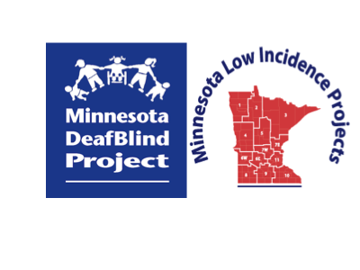

# Minnesota Teachers of Students Who Are DeafBlind

# Community of Practice

## Friday, September 29, 2023

## 9:00 a.m. - 3:00 p.m.

## PIVOT to Virtual in Zoom

## [Zoom Link](https://brightworksmn-org.zoom.us/j/87964493717?pwd=aWRFZlptbUNGdmZSM3pJdU9MWFJLQT09)

## This workshop has no cost to participants.

## Agenda:

**9:00-10:00** **Welcome and New Resources:**

**Google Sites:**

1. “DeafBlind Resources for Special Educators” to replace the Google Shared Drive “MN DeafBlind Resources for Special Educators” – Ann Mayes
   * Combined Hearing and Vision Loss: Resources for Supporting Teams, Including Simulations

2. “School District Resources for Employing Interveners” - Ann Mayes

**Document:**

“Clarification of Roles of Contracted Nurses, District Health Staff, and Interveners in Educational Settings” – Ann Mayes

**Q & A about New Google Sites and Document – How to Share Information as a Representative**

**10:00-10:10 Break/Switch Presenters**

**10:10-12:00 Communication and the Learner Who Is DeafBlind:** Children and youth who are Deafblind require unique strategies to support their development of concepts and communication. The role of the Intervener includes using these strategies to facilitate a student’s access to their environment- including the people, materials, and information within that environment. This presentation will use videos, discussions, and fact sheets to illustrate techniques for any educational team member to support both communication input *and* output with an individual who has unique and sometimes complex communication access needs. Video observations will allow participants to practice identifying the learning and communication styles of individual Deafblind Learners. Discussion will include the consideration of multiple forms of communication to connect, share, and interact as equal partners across motivating topics and experiences. Participants will have the opportunity to reflect on potential “next steps” for expanding their own student’s high-quality interactions.

**\*Note:** The presenter will manage breaks during her presentation.

**12:00-1:00 Lunch Break**

**1:00-2:30 Communication and the Learner Who Is DeafBlind Continues**

**2:30-3:00** **Discussion about Presentation**

**Evaluation and Wrap-Up**

## Registration Information

[**[](https://metroecsu.myquickreg.com/register/event/event.cfm?eventid=16867)**](https://metroecsu.myquickreg.com/register/event/event.cfm?eventid=16178)

**Program and Registration Contact:** Ann Mayes, [ann.mayes@brightworksmn.org](mailto:ann.mayes@metroecsu.org)

**Presenter:**

**Megan Mogan**

Megan is a Deafblind Specialist with the Arizona Deafblind Project. She worked as a Speech-Language Pathologist for 18 years at the Arizona State School for the Deaf and Blind-Tucson campus and in the Sunnyside Unified School District in Tucson. She presents across the nation on strategies related to literacy and communication for children and youth at the earliest levels of communication. Megan was the recipient of the Principals of Schools for the Blind 2017 “Outstanding Related Service Provider.” She lives in Tucson with her husband, 3 teenage kids, and a bull terrier rescue named Humphrey.

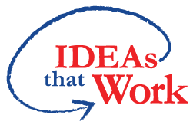 Funding for this workshop is made possible with a grant from the MN Department of Education. The source of the funds is the federal award Special Education – Programs to States, CFDA 84.027A Special Education. And federal award – Project Title: Technical Assistance and Dissemination to Improve Services and Results for Children with Disabilities CFDA 84.326T of P.L. 108-446 Individuals with Disabilities Education Act.